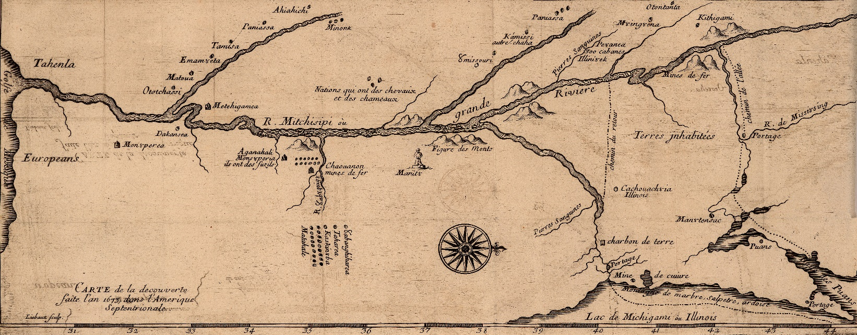

**Home Vita Publications Public Talks Consulting & Media Contact**

**Public Talks**

Professional historians must engage with the broader society and share their research and insights. For this reason, I have put together a series of public talks that examine a variety of topics. They are designed to make people stop, think, and consider the broader implications of the human past.

Interested in booking a talk? Click here and contact me. I am always interested in hearing from you!

**General History**

***Debunking Conspiracy Theories***

Conspiracy theories are a form of misinformation that have plagued human societies since the beginning of time. They have the potential to do great harm and often lead to violence. Why do they exist? What have been some of the major conspiracy theories of our age? This presentation answers those questions.

***Hitler’s Forgotten Holocaust: The Soviet Union during World War II***

Everyone is familiar with the fact Adolf Hitler ordered the annihilation of 6 million Jews during World War II. They are often surprised and shocked to learn that 25 million Soviet citizens died during this conflict. This topic explores a facet of the Second World War that is unknown to most Americans. The German army killed millions of Soviet citizens, both military and non-military, as it blazed a path of destruction across East Europe. This talk looks at the causes of this violent and bloody aspect of the war.

***Public Torture and Execution: Europe and Native North America Compared***

Four centuries ago, both American Indians and early modern Europeans practiced forms of public torture and execution. These customs seem barbaric to us, but they had a logic and purpose, or, more accurately, they had logics and purposes. While public torture and execution by both societies appeared similar, to Europeans and American Indians they had radically different meanings that are examined in this talk.

***Witches and Witchcraft in History***

Popular images of witches in movies such as *The Wizard of Oz* and shows such as *Sabrina the Teenage Witch* have shaped our perceptions of witches for almost a century. Of course, most people have heard of the Salem Witch Trials of 1692, and they may even know about similar “witch hunts” in Europe about the same time. However, witches can be found in many societies around the globe. This presentation looks at the cultural forces that have shaped beliefs concerning witches and witchcraft in many cultures throughout history.

**Art History**

***The Art of Nazi Germany***

From the end of World War II to the 1980s, historians paid the art of the Nazi era little heed. They saw it as regressive and imitative; they saw it as little more than propaganda for a dictatorial regime. Since the 1990s, art scholars have examined Nazi-era art more closely and now realize that much of it exhibited aspects of twentieth-century modernism. Contrary to popular belief, very little of this art was overtly political or fascist. This talk explores a fascinating and little-known subject.

***German Industrial Art of the Early Twentieth Century***

In 1875, the German artist Adolph Menzel completed his famous painting *Iron Rolling Mill* and initiated a new style and school of painting that would be unique to German art for the next half century. Industrial art sought to depict the mighty factories of the Ruhr Valley and other German industrial districts as temples of national strength and technological savvy. This talk examines the rise and fall of the ‘Heroic School’ of German industrial art.

***Erich Mercker: German Landscape and Industrial Painter***

Erich Mercker’s fifty-year career as a painter in Germany spanned several crucial eras. He was born into a Germany under the Kaiser, witnessed his country’s tragic loss during World War I, lived through the chaos and upheaval of the Weimar era, and reached dizzying heights of success under the Third Reich. All this success ended with the destruction of Nazi Germany in 1945. This talk looks at the landscape and industrial paintings that defined Mercker’s art.

**History of the Midwest**

***The Black Hawk War of 1832***

From May to August 1832, the United States fought the Sauk and Meskwaki Indians led by Black Hawk. This short but violent war resulted in the deaths of almost five hundred Native American people who followed Black Hawk. While contemporary residents of Illinois and Wisconsin have heard of this conflict, they often know little about it. This talk provides a solid historical overview of the Black Hawk War.

***Bondage in the Land of the Free: Slavery in Wisconsin Before the Civil War***

Most people tend to associate Wisconsin with the Union and the destruction of slavery during the Civil War. Many people are surprised to learn that Wisconsin and other states of the Midwest allowed slavery in the decades before the Civil War. This talk examines the institution of slavery as practiced by the American Indian and French communities in the centuries before Anglo-American settlement after the War of 1812, and the tolerance toward slavery among the first white settlers who made Wisconsin home between 1815 and 1848.

***Jean Nicolet: French Explorer and Diplomat***

The word “Nicolet” is affixed to many place names in Wisconsin: streets, schools, and even a national forest. Who was Jean Nicolet, and why did he undertake a journey to Wisconsin in 1634? Why are there so many debates as to the location of his final landfall? This presentation answers these questions about this fascinating historical figure.

***The French History of Wisconsin, 1634-1840***

For over two centuries, the French were the second largest group in Wisconsin after the American Indians. Upon their arrival, the French forged deep and intimate ties with the Indian communities of Wisconsin. The two groups heavily intermarried and in the process created a new people, the Métis, a biracial society that borrowed heavily from both American Indian and French cultures. While France ceded its North American empire to Britain in 1763, the French continued to have a strong presence in Wisconsin at fur trade centers such as Green Bay and Prairie du Chien until the advent of large-scale white settlement in the 1840s.